**CAMPUS RECRUITMENT PORTAL**

*Submitted in the partial fulfillment of the requirements*

*For the award of the degree in*

**BACHELOR OF TECHNOLOGY**

In

**Computer Science & Engineering**

By

P.Smruthi (10H51A0541)

S.Lata (105H1A0530)

M.Chaitra Sailaja (10H51A0532)

Under the guidance of

Mrs.E.V.N.Jyothi

Assistant Professor



**DEPARTMENT OF COMPUTER SCIENCE & ENGINEERING**

**CMR COLLEGE OF ENGINEERING & TECHNOLOGY**

**(Affiliated To JNTU Hyderabad)**

**Kandlakoya (V), Medchal Road, Hyderabad.**



**CMR COLLEGE OF ENGINEERING & TECHNOLOGY**

Kandlakoya (V), Medchal Road, Hyderabad

**DEPARTMENT OF COMPUTER SCIENCE AND ENGINEERING**

**BONAFIDE CERTIFICATE**

This is to certify that this Project Report is the bonafide work of **P.SMRUTHI (10H51A0541), S.LATA (10H51A0530), M.CHAITRA SAILAJA (10H51A0532)** of IV B.Tech CSE, who carried out the project entitled **“CAMPUS RECRUITMENT PORTAL”** is submitted in partial fulfillment of the requirements for the award of the degree in BACHELOR OF TECHNOLOGY in Computer Science & Engineering, CMR College of Engineering & Technology, Hyderabad during the Academic Year 2013-2014

**Mrs.E.V.N.Jyothi Mr.K.Srinivas Rao**

**Assistant Professor Head of the Department**

**Internal Guide CSE Department**

**Submitted for Viva Voce Examination held on_________________**

**Internal Examiner External Examiner**

**ACKNOWLEDGEMENT**

It plunges us in exhilaration in taking privilege in expressing our heartfelt gratitude to our Project Coordinator, **Mrs. T. Sahana Edwin** her extreme support, guidance and timely inspiration in making this project successful.

We also reveal our deepest gratitude to our project guide, **E.V.N.Jyothi,** for her extreme support, guidance and timely inspiration in making this project successful.

We express our sincere gratitude to **Idealabs of Renaissance Soft Labs**, for its kind acceptance in providing us project successfully and providing us with encouraging guidance throughout.

Our sincere thanks to the Head of the Department, Computer Science & Engineering, **Prof. K. Srinivas Rao,** CMR College of Engineering & Technology, JNTUH for providing us his assistance and necessary facilities for carrying out this project successfully.

It plunges us in exhilaration in taking privilege in expressing our heartfelt gratitude to our Principal **Prof. Dr. M. Rama Linga Reddy**, CMR College of Engineering & Technology, JNTUH, for helping us finishing out this project successfully.

With pleasure, we also wish to convey our thanks to all those, who directly or indirectly contributed their assistance in finishing this project successfully.

**P.Smruthi (10H51A0541)**

**S.Lata (10H51A0530)**

**M.Chaitra Sailaja (10H51A0532)**

**ABSTRACT**

Campus recruitment Portal is a web application where the student can get the details about the company which is going to visit their campus. The company profile includes details of the company, skills required, eligibility criteria etc. The students can check whether they are eligible for a particular company or not in a single click. The students also have an option of taking company specific mock tests. This portal also includes training details such as company name, timings, venue etc.

The main objective of this application is that the student can check whether he is eligible for a particular company or not in a single click. And the student need not wait for the hall ticket, once the student is eligible a hall ticket is automatically generated. The student is provided with a download of hall ticket option in the portal itself.

The main advantage of this application is it is very user friendly. This application reduces the burden on placement team of a college. This is because they need not send a mail to each and every student regarding the upcoming drives. The database used in this application is Oracle10g.

**CONTENTS**

**TOPIC PAGE NO**

**1. INTRODUCTION**

1.1 Introduction To Project 1 1.2 Domain 1

1.2.1 Web 1.01

1.2.2 Web 2.0 1

1.2.3 Web 3.0 2

1.2.4 RIA 2

1.2.5 Semantic Web 2

**2. LITERATURE SURVEY**

2.1 JAVA 3 2.1.1 Introduction to JAVA 3 2.1.2 Features of JAVA 3

2.1.2.1 Security 4

2.1.2.2 Portability 4

2.1.2.3 The Byte code 4

2.1.2.4 JVM 4

2.1.2.5 Java Architecture 5

2.1.2.6 Compilation of code 5

2.1.2.7 Object-oriented 5 2.1.2.8 Robust 6

2.2 Eclipse Galileo (3.5) 6

2.3 Oracle 10g Database Server 6

2.3.1 Features 7

2.4 Datanamic dezign database 8

**3. SOFTWARE REQUIREMENT ANALYSIS** 3.1 Existing System 9

3.2 Disadvantages of Existing System 9

3.3 Proposed System 9

3.4 Advantages 10 3.5 Module Description 10

3.6 Feasibility Study 11

3.6.1 Technical Feasibility 11

3.6.2 Operational Feasibility 12

3.6.3 Economical Feasibility 13

3.7 SDLC Life Cycle 13

3.7.1 Iterative Software Engineering Lifecycle 13 3.7.2 Waterfall Lifecycle Model 14

3.7.2.1 Advantages 15

3.7.2.2 Disadvantages 15

3.7.3 Prototype Model 16

3.7.3.1 Advantages 17

3.7.3.2 Disadvantages 17

**4. SOFTWARE DESIGN**

4.1 Introduction 18 4.2 Architecture 18

4.3 UML Diagrams 19

4.3.1 Usecase Diagram 21

4.3.2 Class Diagram 22

4.3.3 Sequence Diagram 24

4.3.4 Collaboration Diagram 28

4.4 Entity Relationship diagrams 30

**5. CODING**

5.1 Code 33

5.2 Table Structures 40

**6. TESTING**

6.1 Introduction 45

6.1.1 Software Testing 45

6.1.2 Test Plan 45

6.2 Testing Methodologies 45

6.2.1 Levels of Testing 45

6.3 Test Methods 46

6.3.1 Unit Testing 46

6.3.2 Integration Testing 47

6.3.3 Validation Testing 47 6.3.4 White Box Testing 47

6.3.5 Black Box Testing 47 6.4 Test Cases 48

**7. OUTPUT SCREENS**

7.1 Home Page 51 7.2 Registration page 52

7.3 Login Page 53

7.4 Upload Resume Page 53 7.5 Profile Page 54

7.6 Upcoming Drives Page 55 7.7 Mock Tests Page 55

7.8 Results Page 56

7.9 Training Details Page 56

7.10 Feedback Page 57

7.11 Admin Login Page 57

7.12 Company Profile Uploading Page 58

7.13 List of Students Placed Page 58

7.14 List of Top Companies Page 59

7.15 Contact Us Page 59

**8. CONCLUSIONS** 60

**9. FUTURE ENHANCEMENTS** 61

* **BIBLIOGRAPHY** 62
* **REFERENCES** 63

**LIST OF FIGURES**

**S.NO DESCRIPTION PAGE NO.**

3.1Iterative Development Model 14

3.2 Waterfall Lifecycle Model 16

4.1 System Design Architecture 19

4.3.1 Usecase Diagram 21

4.3.2 Class Diagram 24

4.3.3 Sequence Diagram 25

4.3.4 Collaboration Diagram 29

4.4 ER Diagram 32

6.1 Levels of Testing 47

**LIST OF TABLES**

**S.NO DESCRIPTION PAGE NO.**

5.2.1Student_det Table 41

5.2.2 Security_ques Table 41

5.2.3 SSC Table 41

5.2.4 Intermediate Table 42

5.2.5 Graduation Table 42

5.2.6 Resume_file Table 42

5.2.7 Company_details Table 43

5.2.8 Training Table 43

5.2.9 Test Table 43

5.2.10 Question Table 44

5.2.11 Options Table 44

5.2.12 Grades Table 44

5.2.13 Feedback Table 44

**1. INTRODUCTION**

* 1. **INTRODUCTION TO PROJECT**

Campus recruitment Portal is a web application where the student can get the details about the company which is going to visit their campus. The company profile includes details of the company, skills required, eligibility criteria etc. The students can check whether they are eligible for a particular company or not in a single click. The students also have an option of taking company specific mock tests. This portal also includes training details such as company name, timings, venue etc.

* 1. **DOMAIN(WEB 3.0)**

**1.2.1 WEB 1.0**

Web 1.0 was an early stage of the conceptual evolution of the World Wide Web, centered around a top-down approach to the use of the web and its user interface. Socially, users could only view web pages but not contribute to the content of the webpage.

* Think of Web1.0 as a library.(data is not organized)

**1.2.2 WEB 2.0**

Web 2.0 is the term given to describe a second generation of the World Wide Web that is focused on the ability for people to collaborate and share information online. Web 2.0 basically refers to the transition from static HTML Web pages to a more dynamic Web that is more organized and is based on serving Web applications to users. Other improved functionality of Web 2.0 includes open communication with an emphasis on Web-based communities of users, and more open sharing of information. Over time Web 2.0 has been used more as a marketing term than a computer-science-based term.

Blogs, wikis, and Web services are all seen as components of Web 2.0.

* Web2.0 is more like a big group of friends and acquaintances

**1.2.3 WEB 3.0**

* Web 3.0 is a Giant Database of sorted information.
* The core of web 3.0 lies in its ability to act as a guide for Internet users and preventing it from becoming mere a cumbersome database.
* Web 3.0 is going to be like having a Personal assistant who knows practically everything about you and can access all the information on the Internet to answer any question.
* Web 3.0 will use the Internet to make Connections with information
* Web 3.0 has the potential to change the entire process by bringing machines closer to users and producers which would result in more dynamic, interactive and efficient creation of content online as well as the management of that content.
* The major premise of web 3.0 is based upon linking, integrating and analyzing data from various data sources into new information streams.

**1.2.4 RIA**

"Rich Internet applications (RIA) are Web applications that have the features and functionality of traditional desktop applications. RIAs typically transfer the processing

necessary for the user interface to the Web client but keep the bulk of the data (i.e., maintaining the state of the program, the data etc) back on the application server. RIAs typically:

* run in a Web browser, or do not require software installation
* run locally in a secure environment called a sandbox
* Can be "occasionally connected" wandering in and out of hot-spots or from office to office."

**1.2.5 SEMANTIC WEB**

The Semantic Web is a web that is able to describe things in a way that computers can understand**.** The Semantic Web is not about links between web pages. The Semantic Web describes the relationships between things (like A is a part of B and Y is a member of Z) and the properties of things (like size, weight, age, and price).

**2. LITERATURE SURVEY**

**2.1 JAVA**

**2.1.1 INTRODUCTION TO JAVA**

Initially the language was called as “oak” but it was renamed as “Java” in 1995. The primary motivation of this language was the need for a platform-independent (i.e., architecture neutral) language that could be used to create software to be embedded in various consumer electronic devices.

**Java is a programmer’s language.**

* Java is cohesive and consistent.
* Except for those constraints imposed by the Internet environment, Java gives the programmer, full control.
* Finally, Java is to Internet programming where C was to system programming**.**

**2.1.2 FEATURES OF JAVA**

JAVA has the following features.

**2.1.2.1 SECURITY**

Every time you that you download a “normal” program; you are risking a viral infection. Prior to Java, most users did not download executable programs frequently, and those who did scan them for viruses prior to execution. Most users still worried about the possibility of infecting their systems with a virus. In addition, another type of malicious program exists that must be guarded against. This type of program can gather private information, such as credit card numbers, bank account balances, and passwords. Java answers both these concerns by providing a “firewall” between a network application and your computer.

**2.1.2.2 PORTABILITY**

For programs to be dynamically downloaded to all the various types of platforms connected to the Internet, some means of generating portable executable code is needed .As you will see, the same mechanism that helps ensure security also helps create portability. Indeed, Java’s solution to these two problems is both elegant and efficient.

**2.1.2.3 THE BYTE CODE**

The key that allows the Java to solve the security and portability problems is that the output of Java compiler is Byte code. Byte code is a highly optimized set of instructions designed to be executed by the Java run-time system, which is called the Java Virtual Machine (JVM). That is, in its standard form, the JVM is an interpreter for byte code.

Translating a Java program into byte code helps makes it much easier to run a program in a wide variety of environments. The reason is, once the run-time package exists for a given system, any Java program can run on it.

Although Java was designed for interpretation, there is technically nothing about Java that prevents on-the-fly compilation of byte code into native code. Sun has just completed its Just in Time (JIT) compiler for byte code. When the JIT compiler is a part of JVM, it compiles byte code into executable code in real time, on a piece-by-piece, demand basis. It is not possible to compile an entire Java program into executable code all at once, because Java performs various run-time checks that can be done only at run time. The JIT compiles code, as it is needed, during execution.

**2.1.2.4 JVM (JAVA VIRTUAL MACHINE)**

Beyond the language, there is the Java virtual machine. The Java virtual machine is an important element of the Java technology. The virtual machine can be embedded within a web browser or an operating system. Once a piece of Java code is loaded onto a machine, it is verified. As part of the loading process, a class loader is invoked and does byte code verification makes sure that the code that’s has been generated by the compiler will not corrupt the machine that it’s loaded on. Byte code verification takes place at the end of the compilation process to make sure that is all accurate and correct. So byte code verification is integral to the compiling and executing of Java code.

**2.1.2.5 JAVA ARCHITECTURE**

Java architecture provides a portable, robust, high performing environment for development. Java provides portability by compiling the byte codes for the Java Virtual Machine, which is then interpreted on each platform by the run-time environment. Java is a dynamic system, able to load code when needed from a machine in the same room or across the planet.

**2.1.2.6 COMPILATION OF CODE**

When you compile the code, the Java compiler creates machine code (called byte code) for a hypothetical machine called Java Virtual Machine (JVM). The JVM is supposed to execute the byte code. The JVM is created for overcoming the issue of portability. The code is written and compiled for one machine and interpreted on all machines. This machine is called Java Virtual Machine.

During run-time the Java interpreter tricks the byte code file into thinking that it is running on a Java Virtual Machine. In reality this could be an Intel Pentium Windows 95 or Suns ARC station running Solaris or Apple Macintosh running system and all could receive code from any computer through Internet and run the Applets.

**2.1.2.7 OBJECT ORIENTED**

Java was not designed to be source-code compatible with any other language. This allowed the Java team the freedom to design with a blank slate. One outcome of this was a clean usable, pragmatic approach to objects. The object model in Java is simple and easy to extend, while simple types, such as integers, are kept as high-performance non-objects.

**2.1.2.8 ROBUST**

The multi-platform environment of the Web places extraordinary demands on a program, because the program must execute reliably in a variety of systems. The ability to create robust programs was given a high priority in the design of Java. Java is strictly typed language; it checks your code at compile time and run time.

Java virtually eliminates the problems of memory management and de-allocation, which is completely automatic. In a well-written Java program, all run time errors can –and should –be managed by your program.

**2.2 ECLIPSE 3.5(GALILEO)**

**Eclipse** is a commercially available Java EE and AJAX IDE created and maintained by the company Genuitec, a founding member of the Eclipse Foundation

**Eclipse** is a multi-language [software development environment](http://en.wikipedia.org/wiki/Software_development_environment) comprising an [integrated development environment](http://en.wikipedia.org/wiki/Integrated_development_environment) (IDE) and an extensible [plug-in](http://en.wikipedia.org/wiki/Plug-in_(computing)) system. It is written mostly in [Java](http://en.wikipedia.org/wiki/Java_(programming_language)) and can be used to develop applications in Java. Eclipse employs plug-ins in order to provide all of its functionality on top of (and including) the runtime system, in contrast to some other applications where functionality is typically [hard coded](http://en.wikipedia.org/wiki/Hard_code). The runtime system of Eclipse is based on [Equinox](http://en.wikipedia.org/wiki/Equinox_(OSGi)), an [OSG](http://en.wikipedia.org/wiki/OSGi)  standard compliant implementation. This plug-in mechanism is a lightweight [software componentry](http://en.wikipedia.org/wiki/Software_componentry) framework. In addition to allowing Eclipse to be extended using other [programming languages](http://en.wikipedia.org/wiki/Programming_language) such as [C](http://en.wikipedia.org/wiki/C_(programming_language)) and [Python](http://en.wikipedia.org/wiki/Python_(programming_language)), the plug-in framework allows Eclipse to work with typesetting languages like [LaTeX](http://en.wikipedia.org/wiki/LaTeX), networking applications such as [telnet](http://en.wikipedia.org/wiki/Telnet), and [database management systems](http://en.wikipedia.org/wiki/Database_management_system).

**2.3 ORACLE 10G DATABASE SERVER**

Oracle Database 10g is Oracle’s revolutionary new grid offering for database administrators, which include breakthrough self-management, storage management, and clustering features. It is designed to relieve system administrators from repetitive, low-value administrative work and provide them with an opportunity to increase their value and expand their technical skills. The new Oracle University curriculum tracks for Oracle Database 10g are tailored to the scale and needs of customers’ data centers. These new courses target current and new Oracle Database Administrators and provide training in half the time and half the cost.

**2.3.1 FEATURES**

There are too many Oracle 10g SQL new features to be able to cover them all here so we've just picked out a few of the more interesting ones as well as a few SQL*Plus new features.

In brief, the SQL new features and enhancements we'll be looking at are:

* [writeable external tables](http://www.asktheoracle.net/oracle-10g-sql-new-features.html#external_table)
* [restore points and flashback queries](http://www.asktheoracle.net/oracle-10g-sql-new-features.html#Restore_Points_and_Flashback_Query)
* [regular expression support](http://www.asktheoracle.net/oracle-10g-sql-new-features.html#Regular_Expression_Support)

The Oracle 10g new features can be organized into 5 broad categories:

1. **Manageability/automation** -in other words decreasing the amount of time spent on routine tasks to leave more time for strategic tasks

* Common Manageability Infrastructure
* Storage Enhancements
* Space Management
* Other Manageability Enhancements
* Human Error Correction (including [flashback database](http://www.asktheoracle.net/oracle-10g-new-features-flashback-db.html))

1. **Availability**

* Recovery through reset logs
* Backup and recovery
* Data Guard
* Online redefinition
* Log Miner

1. **Performance**

* Resource Manager
* Wait interface enhancements
* End to end application testing
* SQL tuning advisor

1. **Business Intelligence/Data Warehousing**

* Materialized view refresh and query rewrite
* Asynchronous change data capture
* Materialized view refresh and query rewrite

1. **Application Development**

* [SQL and SQL*PLUS](http://www.asktheoracle.net/oracle-10g-sql-new-features.html)
* [PLSQL](http://www.asktheoracle.net/oracle-10g-plsql-new-features.html)

**2.4 DATANAMIC DEZIGN DATABASE**

DeZign for Databases is an intuitive database design and modeling tool for developers and DBA's that can help you model, create and maintain databases. The software uses entity relationship diagrams (ERDs, data models) to graphically design databases and automatically generates the most popular SQL and desktop databases.

DeZign for Databases offers a sophisticated visual data modeling environment for database application development that makes your database development process much easier. The tool reduces faults in database development and improves your productivity. You can visualize database structures to understand your database, create new databases or reverse-engineer existing databases to modify, document, analyze, and optimize. The tool is extremely easy to use. Whether you are a beginner or an expert database modeler, you will find your way in the tool very easily. DeZign for Databases provides all the features you expect in a professional database modeling and design tool.

**3. SOFTWARE REQUIREMENT ANALYSIS**

**3.1 EXISTING SYSTEM**

In the current scenario, the placement cell of a college sends a mail to all the students about the company’s details which is going to visit the campus. Then the students view these details and register if they meet the company’s eligibility criteria. After their registration is approved they receive admit card to their respective mail id’s.

**3.2 DISADVANTAGES OF THE EXISTING SYSTEM**

* In this current system, we make use of many resources like excel sheets, mails etc.
* It is a long and tiresome procedure.
* We can get the details of the company only in company specific website.
* We need to search for company specific papers in another website which is a waste of time.
* We need to register for the company and wait for the admit card.

**3.3 PROPOSED SYSTEM**

Campus Recruitment Portal maintains all the academic details of each student. It also maintains details of the company which is going to visit the campus so that student can view the company’s details. The student can check whether he eligible for a particular company or not. The students have an option of writing company specific mock tests. This portal also maintains training details such as company name, timings, venue etc.

**3.4 ADVANTAGES**

* It is more user friendly as the whole information is present in a single site.
* It saves lot of time.
* Students can access the company profile and check their eligibility directly.
* They can also get the admit card in this site.
* Students can check their performance by writing the company’s specific mock tests.

**3.5 MODULE DESCRIPTION**

Campus recruitment Portal is a web application where the student can get the details about the company which is going to visit their campus. The company profile includes details of the company, skills required, eligibility criteria etc. The students can check whether they are eligible for a particular company or not in a single click. The students also have an option of taking company specific mock tests.

**List of modules:**

1. Student Registration
2. Company Management
3. Test Management
4. Feedback
5. **Student Registration**

In this module, student registers with all his personal and academic details. Then the student logs in with userid and password. The student can view and edit his profile. And the student uploads his resume in this module.

1. **Company Management**

In this module, admin uploads the company details which is going to visit their campus. The student can view these company details. If the student is eligible for a particular company an admit card is generated automatically.

1. **Test Management**

Here the admin uploads the company specific test papers. The students can select the company name and take the test. The student can view the results.

1. **Feedback**

In this module, the student can give suggestions and feedback. The student can also rate the portal.

**3.6 FEASIBILITY STUDY**

A feasibility study is a high-level capsule version of the entire system analysis and design process. The study begins by classifying the problem definition. Feasibility is to determine if it’s worth doing. Once an acceptance problem is generated, the analyst develops a logical model of the system. A search for alternative is analyzed carefully.

There are 3 parts in feasibility study

* Technical Feasibility
* Operational Feasibility
* Economical Feasibility

**3.6.1 TECHNICAL FEASIBILITY**

Evaluating the technical feasibility is the trickiest part of a feasibility study. This is because, at this point in time, not too many detailed design of the system, making it difficult to access issues like performance, costs on ( on account of kind of technology to be deployed ) etc.

A number of issues have to be considered while doing a technical analysis:

1. **Understand the different technologies involved in the proposed system:**

Before commencing the project, we have to be very clear about what are the Technologies that are to be required for the development of the new system.

1. **Find out whether the organization currently possess the required technologies:**

Is the required technology available with the organization?If so is the capacity sufficient?

For instance –“Will the application work efficiently if the same apk is run on the higher versions of Android?”

**3.6.2 OPERATIONAL FEASIBILTY**

Proposed projects are beneficial only if they can be turned into information systems that will meet the organizations operating requirements. Simply stated, this test of feasibility asks if the system will work when it is developed and installed. Are there major barriers to implementation? Here the questions that will help test the operational feasibility of a project:

* Is there sufficient support for the project from management from users? If the current system is well liked and used to the extent that persons will not be able to see reasons for change, there may be resistance.
* Are the current business methods acceptable to the user? If they are not, Users may welcome a change that will bring about a more operational and useful systems.
* Have the user been involved in the planning and development of the project?

Early involvement reduces the chances of resistance to the system and in general and increases the likelihood of successful project. In the existing system, the new system was considered to be operational feasible.

* + 1. **ECONOMIC FEASIBILITY**

Economic feasibility attempts to weigh the costs of developing and implementing new system, against the benefits that would accrue from having the new system in place. This feasibility study gives the top management the economic justification for the new system.

A simple economic analysis which gives the actual comparisons of costs and benefits are much more meaningful in this case. In addition, this proves to be a useful point of reference to compare actual costs as the project progresses. There could be various types of intangible benefits on account of automation. These could include increased customer satisfaction, improvement in product quality better decision making timeliness of information, expediting activities, improved accuracy of operations, better documentation and record keeping, faster retrieval of information, better employee morale.

**3.7 SDLC LIFE CYCLE**

**3.7.1 THE INCREMENTAL, ITERATIVE SOFTWARE ENGINEERING LIFE CYCLE**

The basic idea behind this method is to develop a system through repeated cycles (iterative) and in smaller portions at a time (incremental), allowing software to take advantage of what was learned during development of earlier parts or versions of the system. Learning comes from both the development and use of the system, where possible key steps in the process start with a simple implementation of a subset of the software requirements and iteratively enhance the evolving versions until the full system is implemented. At each iteration, design modifications are made and new functional capabilities are added.

The iteration involves the redesign and implementation of iteration is to be simple, straightforward, and modular, supporting redesign at that stage or as a task added to the project control list. The level of design detail is not dictated by the iterative approach. In a light-weight iterative project the code may represent the major source of documentation of the system; however, in a critical iterative project a formal Software Design Document may be used. The analysis of iteration is based upon user feedback, and the program analysis facilities available. It involves analysis of the structure, modularity, usability, reliability, efficiency, & achievement of goals. The project control list is modified in light of the analysis results.

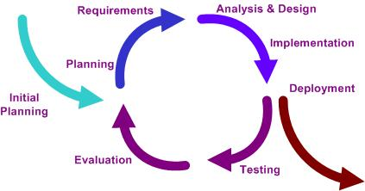

**3.1 Fig:** An iterative development model

**3.7.2 WATERFALL LIFECYCLEMODEL**

The Waterfall Model was first Process Model to be introduced. The waterfall model is a sequential design process, often used in software development processes, in which progress is seen as flowing steadily downwards (like a waterfall) through the phases of Initiation, Analysis, Design, Construction, Testing, Production, and Maintenance. It is also referred to as a linear-sequential life cycle model. It is very simple to understand and use. In a waterfall model, each phase must be completed before the next phase can begin and there is no overlapping in the phases. Waterfall model is the earliest SDLC approach that was used for software development.

The waterfall Model illustrates the software development process in a linear sequential flow; hence it is also referred to as a linear-sequential life cycle model. This means that any phase in the development process begins only if the previous phase is complete. In waterfall model phases do not overlap. Waterfall approach was first SDLC Model to be used widely in Software Engineering to ensure success of the project. In "The Waterfall" approach, the whole process of software development is divided into separate phases. In Waterfall model, typically, the outcome of one phase acts as the input for the next phase sequentially.

**3.7.2.1 ADVANTAGES**

* This model is very easy to use and implement.
* Each phase is completed at a time and processed.
* This model better works for smaller projects if only the requirements are well understood.

**3.7.2.2 DISADVANTAGES**

* If the requirements are gathered are inaccurate then the final product is inaccurate and the error is known in the final phase of the model. Any sort o errors that cannot be detected in any previous phase.
* For long, object-oriented, complex and ongoing projects it’s a poor model.

Initiation

Analysis

Design

Construction

Testing

Production

Maintenance

**3.2 Fig:** Waterfall Lifecycle Model

**3.7.3 PROTOTYPE MODEL**

In this model the requirements are gathered firstly, and the prototype is deployed according to the requirements. This prototype is a quick design which goes through the coding, design and testing. The phases are not done in detail. By seeing this prototype the client feels like a real system, so that the client understands the entire requirements of the system. Software prototyping is the development approach of activities during software development, the creation of prototypes, i.e., incomplete versions of the software program being developed. In this model the user is involved throughout the development process, which increases the likelihood of user acceptance of the final implementation. Small-scale mock-ups of the system are developed following an iterative modification process until the Prototype evolves to meet the user’s requirement. While most prototypes are developed with the expectation that they will be discarded, it is possible in some cases to evolve from prototype to working system. In prototyping Attempts to reduce inherent project risk by breaking a project into smaller segments and providing more ease-of-change during the development process.

**3.7.3.1 ADVANTAGES**

* During the development process the developers are interestingly engaged.
* The prototype developed that is used by the users for well understanding of the methodology.
* The user involvement is increased and improved.
* The flaws and faults are identified early.
* The user’s opinion about the product is known early which leads to an improved system.

**3.7.3.2 DISADVANTAGES**

* This model focuses on design quite than functionality.
* The model is implemented firstly and then errors are evaluated later which becomes a complex process.
* The model is also known as throw-away prototype.

**4. SOFTWARE DESIGN**

**4.1 INTRODUCTION**

Software design sits at the technical kernel of the software engineering process and is applied regardless of the development paradigm and area of application. Design is the first step in the development phase for any engineered product or system. The designer’s goal is to produce a model or representation of an entity that will later be built. Beginning, once system requirement have been specified and analyzed, system design is the first of the three technical activities -design, code and test that is required to build and verify software.

The importance can be stated with a single word “Quality”. Design is the place where quality is fostered in software development. Design provides us with representations of software that can assess for quality. Design is the only way that we can accurately translate a customer’s view into a finished software product or system. Software design serves as a foundation for all the software engineering steps that follow. Without a strong design we risk building an unstable system – one that will be difficult to test, one whose quality cannot be assessed until the last stage.

During design, progressive refinement of data structure, program structure, and procedural details are developed reviewed and documented. System design can be viewed from either technical or project management perspective. From the technical point of view, design is comprised of four activities – architectural design, data structure design, interface design and procedural design.

**4.2 ARCHITECTURE**

The three-tier architecture was comes into existence to improve management of code and contents and to improve the performance of the web based applications. There are mainly three layers in three-tier architecture.

These are defined as follows:

1. Presentation.
2. Business Logic.
3. Database.

1.  **Presentation:** First layer Presentation contains mainly the interface code, and this is shown to user. This code could contain any technology that can be used on the client side like HTML, JavaScript or VBScript etc.

2. **Business Logic** : Second layer is Business Logic which contains all the code of the server-side .This layer have code to interact with database and to query, manipulate, pass data to user interface and handle any input from the UI as well.

3. **Database** : Third layer Data represents the data store like MS Access, SQL Server, an XML file, an Excel file or even a text file containing data also some additional database are also added to that layers.

**Database**

**Presentation Layer**

**Business Logic**

**Fig 4.1:** Architecture

**4.3 UML DIAGRAMS**

The unified modeling language is the industry-standard language for specifying, visualizing, constructing and documenting the artifacts of software systems. It simplifies the complex process of software design, creating a” blue print” for construction. This object oriented system of notation has evolved from the work of Grady Booch, James Rum Baugh, Ivar Jacobson, and the rational software corporation. These renowned compute scientists fused their respective into a single, standardized model.

Today, UML is accepted by the object management group (ONG) as the standard for the modeling object oriented. While UML was designed to specify, visualize, construct and document software-intensive systems, UML is not restricted to modeling software. UML has its strengths at higher, more architectural levels and has been used for modeling hardware and is commonly used for business modeling and representing organizational structure.

**Goals of UML**

The primary goals in the design of the UML were:

* Provides users with a ready-to-use, expensive visual modeling language so they can develop and exchange meaningful models.
* Provide extensibility and specialization mechanisms to extend the core concepts.
* Be independent of particular programming languages and development processes.
* Provide a formal basis for understanding the modeling language.
* Encouraging the growth of object oriented tools market.
* Support higher-level development concepts such as collaborations, frameworks, patterns and components.
* Ingrate best practices.

**Why do we use UML?**

As the strategic value of software increases for many companies, the industry looks for techniques to automate the production of software and to improve quality and reduce cost and time-to-market. These techniques include component technology, visual programming, patterns, and frameworks. Businesses also seek techniques to manage the complexity of systems as they increase in scope and scale. In particular, they recognize the need to solve recurring architectural problems, such as physical distribution, concurrency, replication, security, load balancing and fault tolerance. Additionally, the development for the World Wide Web, while making some things simpler, has exhausted these architectural problems. The Unified Modeling Language (UML) was designed to respond to these needs.

The underlying premise of UML is that no one diagram can capture the different elements of a system in its entirety. Hence, UML is made up of nine diagrams that can be used to model a system at different points of time in the software lifecycle of a system.

**4.3.1 USECASE DIAGRAM**

Use case is a set of scenarios that describing an interaction between a user and a system. A **use case diagram** displays the relationship among actors and use cases.

**Use case Diagram for Student Registration**

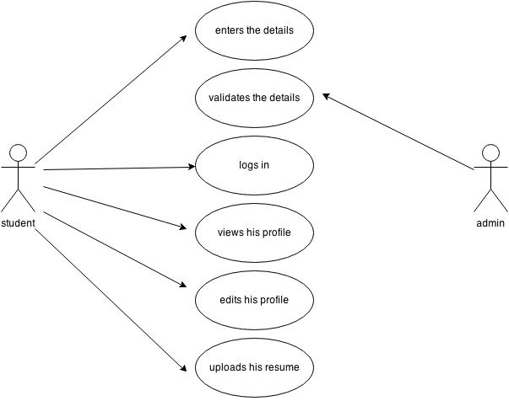

**Use case Diagram for Company Management**

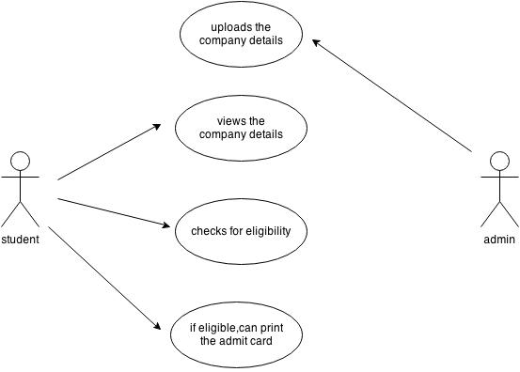

**Use case diagram for Test Management**

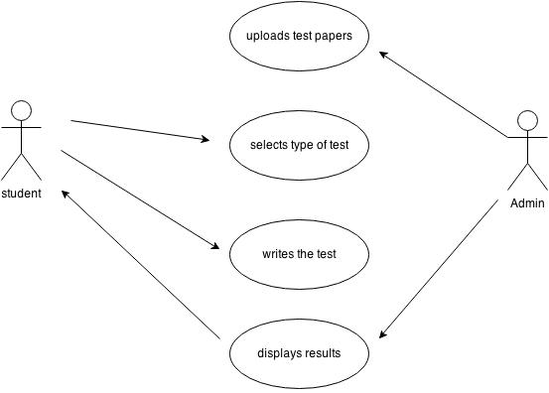

**Use case diagram for Feedback**

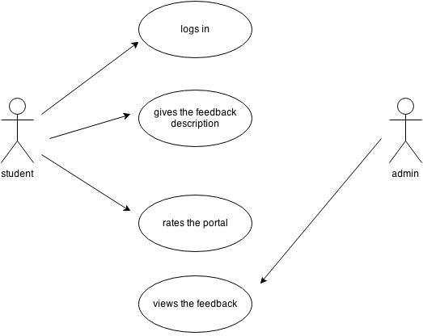

**4.3.2 CLASS DIAGRAM**

In the unified modeling language (UML), a class diagram is a type of static structure diagram that describes the structure of a system by showing the system’s classes, their attributes and their relationships between the classes.

**RELATIONSHIPS**

**Association**

The Association relationship is the most common relationship in a class diagram. The association shows the relationship between instances and classes.

**Generalization**

Class diagram showing generalization between one super class and two sub classes. The generalization relationship indicates that one of the two related classes (“parent”, super class) is considered to be more general form of the other (“child”, subclass). In practice, this means that any instance of the subtype is also an instance of the super type.

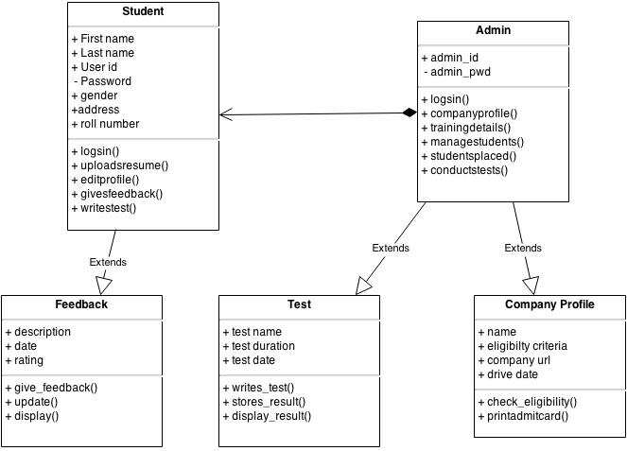

**4.3.3 SEQUENCE DIAGRAM**

It shows, as parallel vertical lines, different processes or objects that live simultaneously, and, as horizontal arrows, the messages exchanged between them, in the order in which they occur

**Sequence Diagram for Student Registration**

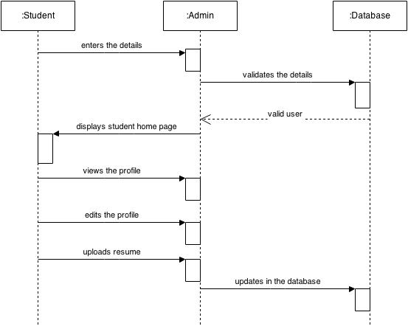

**Sequence Diagram for Company Management**

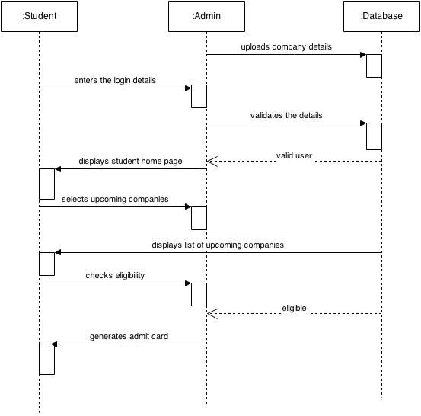

**Sequence Diagram for Test Management**

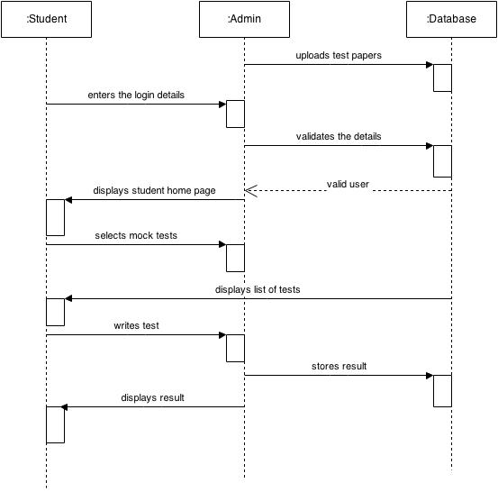

**Sequence diagram for feedback**

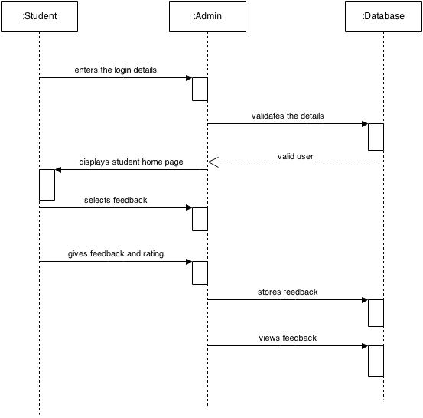

**4.3.4 COLLABORATION DIAGRAM**

Collaboration diagram displays an interaction organized around the objects and their links to one another. Numbers are used to show the sequence of messages.

**Collaboration Diagram for Student Registration**

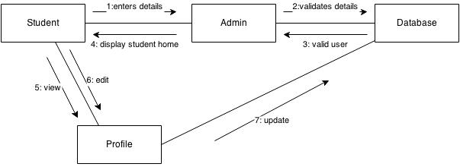

**Collaboration Diagram for Company Management**

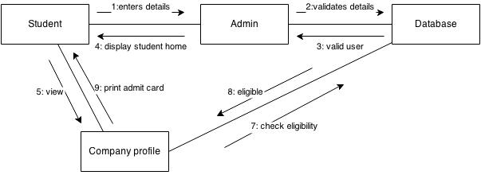

**Collaboration Diagram for Test Management**

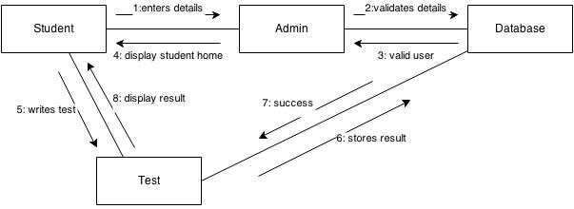

**Collaboration Diagram for Feedback**

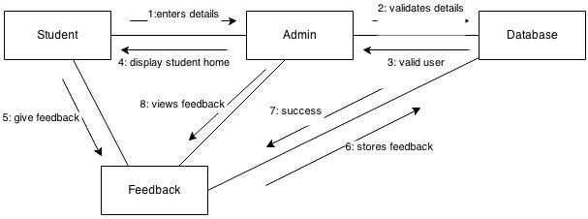

**4.4 ER (ENTITY RELATIONSHIP) DIAGRAM**

The Entity-Relationship Diagram depicts a relationship between data objects. The ERD is the notation that is used to conduct the data modeling activity. The attributes of each data object noted in the ERD can be described using a data object description. The corner stone notation for data modeling is the entity-relationship diagram. The set of primary components for the E-R diagram: data objects attributes, relationships and various type indicators. The primary purpose of the E-R diagram is to represent data objects and their relationships.

E-R diagram notation is relatively simple. Data objects are represented by labeled rectangles. Relationships are indicated with diamonds. Connections between data objects and relationships are established using a variety of special connection lines.

Basic objects in the logical model are:

* Entities
* Attributes
* Relationships

**Entity**

An entity is a logical object that represents a person, place or thing about which an organization maintains information.

**Attributes**

Attributes collect information about an entity. Logical attributes usually correspond to physical columns in a table.

**Relationships**

A very important object in a data model is the relationship, which is represented by the solid or dashed line that connects two entities or two tables. A relationship line connects a parent and child entity or a table.

Basic objects in the physical model are:

**Table**

An entity in the logical model usually corresponds to a table in a physical data model. In the physical model, a graphic box represents a table in which data is stored in the database.

**Columns**

Columns collect information about a table.

**Views**

In a physical model, you can create a view, which is really a SQL query that is permanently stored in the database. Typically, a view is used to present specific database information for target audience.

**The ER diagram of our project is**

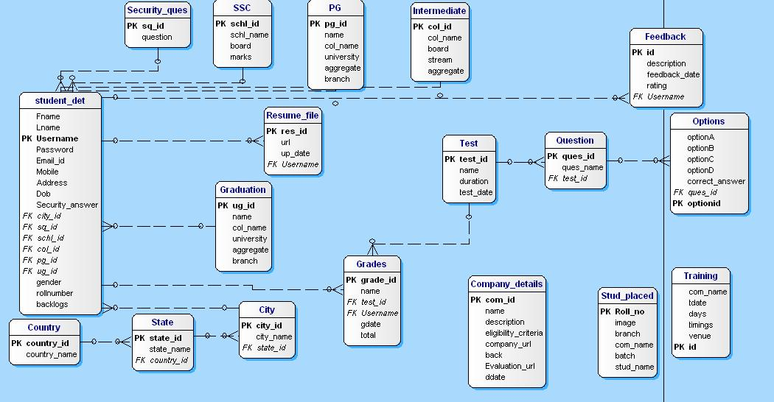

**5. CODING**

**5.1 CODE**

**CheckEligibilty.java:**

package com.controller;

import java.io.IOException;

import java.io.PrintWriter;

import java.sql.Connection;

import java.sql.ResultSet;

import java.sql.SQLException;

import java.sql.Statement;

import javax.servlet.ServletException;

import javax.servlet.http.HttpServlet;

import javax.servlet.http.HttpServletRequest;

import javax.servlet.http.HttpServletResponse;

import javax.servlet.http.HttpSession;

import com.model.conn;

public class checkEligibility extends HttpServlet {

private static final long serialVersionUID = 1L;

public checkEligibility() {

super();

// TODO Auto-generated constructor stub

}

protected void doGet(HttpServletRequest request, HttpServletResponse response) throws ServletException, IOException {

// TODO Auto-generated method stub

HttpSession ses=request.getSession(false);

String uname=(String)ses.getAttribute("uname");

String id=request.getParameter("action");

System.out.println("id is"+id);

Connection con=null;

Statement st=null;

ResultSet rs=null;

PrintWriter pw=response.getWriter();

String per=null;

String per1=null;

String per2=null;

String per3=null;

String per4=null;

String back=null;

String cback=null;

int p=0;

int p1=0;

int p2=0;

int p3=0;

int p4=0;

int b1=0;

int cb=0;

con=conn.getMyconnection();

try {

st=con.createStatement();

String query="select eligibility_criteria,back from company_details where com_id='"+id+"'";

System.out.println("q1 is"+query);

rs=st.executeQuery(query);

while(rs.next()) {

per=rs.getString(1);

cback=rs.getString(2);

}

p=Integer.parseInt(per);

cb=Integer.parseInt(cback);

String q1="select s.marks,st.username from ssc s,student_det st where s.schl_id=st.schl_id and st.username='"+uname+"'";

System.out.println("q2 is"+q1);

rs=st.executeQuery(q1);

while(rs.next())

{

per1=rs.getString(1);

}

p1=Integer.parseInt(per1);

String q2="select i.aggregate,st.username from intermediate i,student_det st where i.col_id=st.col_id and st.username='"+uname+"' " ;

System.out.println("q3 is"+q2);

rs=st.executeQuery(q2);

while(rs.next())

{

per2=rs.getString(1);

}

p2=Integer.parseInt(per2);

String q3="select ug.aggregate,st.username from graduation ug,student_det st where ug.ug_id=st.ug_id and st.username='"+uname+"' ";

System.out.println("q4 is"+q3);

rs=st.executeQuery(q3);

while(rs.next())

{

per3=rs.getString(1);

}

p3=Integer.parseInt(per3);

String q4="select p.aggregate,st.username from pg p,student_det st where p.pg_id=st.pg_id and st.username='"+uname+"' ";

System.out.println("q5 is"+q4);

rs=st.executeQuery(q4);

while(rs.next())

{

per4=rs.getString(1);

System.out.println("per4 is"+per4);

}

String q5="select backlogs from student_det where username='"+uname+"'";

System.out.println("q6 is"+q5);

rs=st.executeQuery(q5);

while(rs.next())

{

back=rs.getString(1);

System.out.println("back is"+per4);

}

b1=Integer.parseInt(back);

if(per4.equals("null"))

{

System.out.println("nopg");

System.out.println("p is"+p);

System.out.println("p1 is"+p1);

System.out.println("p2 is"+p2);

System.out.println("p3 is"+p3);

if((p<=p1)&&(p<=p2)&&(p<=p3)&&(b1<=cb))

{

System.out.println("ureligible");

pw.print("ureligible");

}

else

{

System.out.println("u r not eligible");

System.out.println("in else");

pw.print("u r not eligible");

}

}

else

{

p4=Integer.parseInt(per4);

System.out.println("p is"+p);

System.out.println("p1 is"+p1);

System.out.println("p2 is"+p2);

System.out.println("p3 is"+p3);

System.out.println("p4 is"+p4);

if((p<=p1)&&(p<=p2)&&(p<=p3)&&(p<=p4)&&(b1<=cb))

{

System.out.println("in if");

pw.print("u r eligible");

}

else

{

System.out.println("u r not eligible");

System.out.println("in else");

pw.print("u r not eligible");

}

}

}

catch (SQLException e) {

// TODO Auto-generated catch block

e.printStackTrace();

}

}

protected void doPost(HttpServletRequest request, HttpServletResponse response) throws ServletException, IOException {

// TODO Auto-generated method stub

doGet(request, response);

}

}

**Result.jsp:**

<%@ page language="java" contentType="text/html; charset=ISO-8859-1"

pageEncoding="ISO-8859-1"%>

<!DOCTYPE html>

<%@page import="java.sql.Connection"%>

<%@page import="java.sql.DriverManager"%>

<%@page import="java.sql.Statement"%>

<%@page import="java.sql.ResultSet"%>

<%@page import="com.model.conn"%>

<%@page import="java.util.ArrayList"%>

<%@page import="java.util.Collection"%>

<%@page import="java.io.PrintWriter"%><html>

<head>

<meta http-equiv="Content-Type" content="text/html; charset=ISO-8859-1">

<title>Insert title here</title>

</head>

<body>

<%

ArrayList<String> al=new ArrayList<String>();

ArrayList<String> al1=new ArrayList<String>();

ArrayList<String> al2=new ArrayList<String>();

HttpSession ses=request.getSession(false);

String tid=(String)ses.getAttribute("tid");

String uname=(String)ses.getAttribute("uname");

PrintWriter pw=response.getWriter();

Connection con=null;

Statement st=null;

ResultSet rs=null;

String gid=null;

int marks=0;

int total=0;

con=conn.getMyconnection();

st=con.createStatement();

String qry="select ques_id from question where test_id='"+tid+"'";

System.out.print("query is"+qry);

rs=st.executeQuery(qry);

while(rs.next())

{

al.add(rs.getString(1));

}

total=al.size();

for(String s:al)

{

String query="select correct_answer from options where ques_id='"+s+"'";

System.out.print("query is"+query);

rs=st.executeQuery(query);

while(rs.next())

{

al1.add(rs.getString(1));

}

}

String st1[]=new String[5];

for(int i=0;i<st1.length;i++){

int j=i+1;

st1[i]=request.getParameter("radio"+j);

al2.add(request.getParameter("radio"+j));

System.out.println(st1[i]);

}

System.out.print(al2);

System.out.print(al1);

al1.retainAll(al2);

System.out.print("arraylist is"+al1);

System.out.print("Arraylength is"+al1.size());

marks=al1.size();

String q="select count(*)+1 from grades";

rs=st.executeQuery(q);

if(rs.next())

{

gid=rs.getString(1);

System.out.println("gid is"+gid);

}

Stringq1="insertintogrades values('"+gid+"','"+marks+"','"+tid+"','"+uname+"',sysdate,'"+total+"');

System.out.println("q is"+q1);

int n=st.executeUpdate(q1);

if(n>0)

{

System.out.println("inserted");

pw.println("You have successfully finished your exam.Your result for this test is "+marks+"/"+total);

}%>

</body>

</html>

**5.2 TABLE STRUCTURES**

The tables in this project are given below:

**5.2.1 Student_det Table**

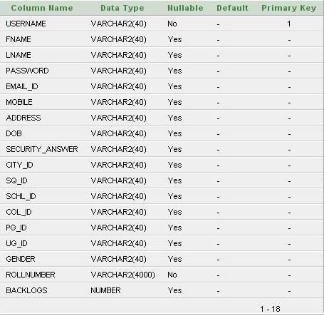

**5.2.2 Security_ques Table**

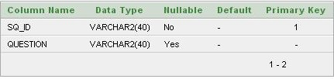

**5.2.3 SSC Table**

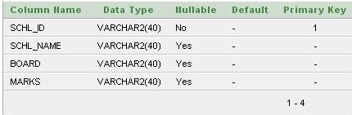

**5.2.4 Intermediate Table**

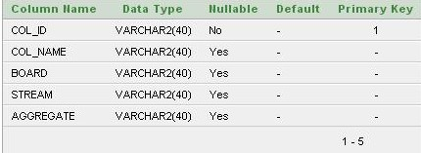

**5.2.5 Graduation Table**

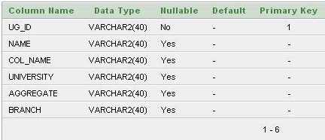

**5.2.6 Resume_file Table**

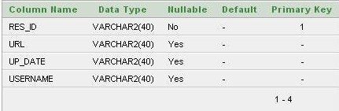

**5.2.7 Company_details Table**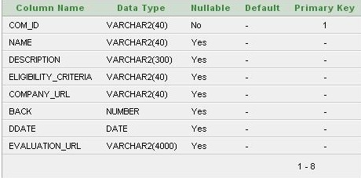

**5.2.8 Training Table**

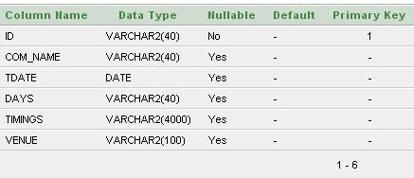

**5.2.8 Test Table**

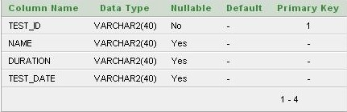

**5.2.9 Question Table**

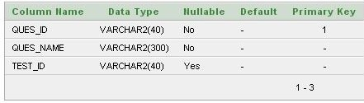

**5.2.10 Options Table**

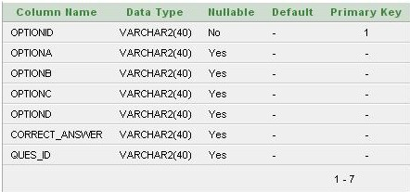

**5.2.11 Grades Table**

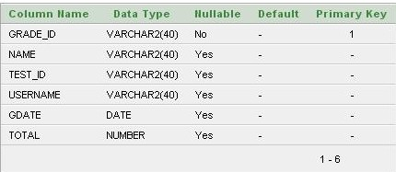

**5.2.12 Feedback Table**

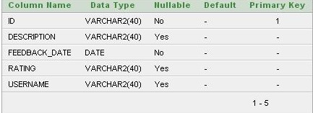

**6. TESTING**

**6.1 INTRODUCTION**

**6.1.1 SOFTWARE TESTING**

Is the menu bar displayed in the appropriate contested some systems related featured included either in menus or tools? Do pull-Down menu operation and Tool-bars work properly? Are all menu function and pull down sub function properly listed Is it possible to invoke each menu function using a logical assumption that if all parts of the system are correct, the goal will be successfully achieved? In adequate testing or non-testing will leads to errors that may appear few months later.

This creates two problems:

* Time delay between the cause and appearance of the problem.
* The effect of the system errors on files and records within the system.

The purpose of the system testing is to consider all the likely variations to which it will be suggested and push the systems to limits. The testing proceeds focuses on the logical intervals of the software ensuring that all statements have been tested and on functional interval is conducting tests to uncover errors and ensure that defined input will produce actual results that agree with the required results. Program level testing, modules level testing integrated and carried out.

**6.1.2 TEST PLAN**

The importance of software testing and its implementations cannot be overemphasized. Software testing is a critical element of Software Quality Assurance and represents the ultimate review of the specifications, design and coding.

**6.2 TESTING METHODOLOGIES**

**6.2.1 LEVELS OF TESTING**

In order to uncover the errors present in the different phases we have the concept of levels of testing. The basic levels of testing are as shown below:

Client Needs

Acceptance Testing

Requirements

System Testing

Design

Integration Testing

Unit Testing

Code

**6.3 TESTING METHODS**

* Unit Testing
* Integration Testing
* Validation Testing
* White Box Testing
* Black Box Testing

**6.3.1 UNIT TESTING**

Unit testing is a software verification and validation method in which a programmer tests if individual units of 0 are fit for use.

A unit is the smallest testable part of an application. In procedural programming a unit may be an individual function or procedure.

Ideally, each test case is independent from the others: substitutes like method stubs, objects, fakes and test harnesses can be used to assist testing a module in isolation.

**6.3.2 INTEGRATION TESTING**

This testing is sometimes called Integration and Testing. Integration testing is the phase in software testing in which individual software modules are combined and tested as a group. It occurs after unit testing and before system testing. Integration testing takes as its input modules that have been unit tested, groups them in larger aggregates, applies tests defined in an integration test plan to those aggregates and delivers as its output the integrated system ready for system testing.

**6.3.3 VALIDATION TESTING**

Validation testing can be defined in many ways, but a simple definition is that validation succeeds when the software function in a manner that can reasonably expected by a customer. After validation test has been conducted, one of the following two possible conditions exists. The functions or performance characteristics confirm to specification and are accepted.

* In the user module, all the fields must be filled.
* In the user module, phone number must be numeric.
* Confirm password and the given password must match.

**6.3.4 WHITE BOX TESTING**

White box sometimes called “Glass Box Testing” is a test case design uses the control structure of the procedural design to drive the test case. Using white box testing methods, the following tests were made on the system.

* All independent paths within a module have been exercised once. In our system, ensuring that case was selected and executed checked all case structures. The bugs that were prevailing in some part of the code where fixed.
* All logical decisions were checked for the truth and falsity of the values.

**6.3.5 BLACK BOX TESTING**

Black box tasting focuses on the functional requirements of the software. This is black box testing enables the software engineering to derive a set of input conditions that will fully exercise all functional requirements for a program. Black box testing is not an alternative to white box testing rather it is complementary approach that is likely to uncover o different class of errors that white box methods like.

* Interface errors
* Performance in data structures
* Performance errors
* Initializing and termination errors.

**6.4 TEST CASES**

Test cases are designed for finding undiscovered error. All the modules are tested against the specification produced during the design for the modules. These modules were tested as a part of unit testing. Test cases are also able to identify inter module impacts.

**Registration Page**

|  |  |  |  |  |
| --- | --- | --- | --- | --- |
| **FUNCTION** | **EXPECTED RESULTS** | **ACTUAL RESULTS** | **REMARKS** | **COMMENTS** |
| Should allow the user to enter his details and click submit button | It redirects the user to the login screen of the website. | It redirects user to the login screen of the website. | Success | The button allows the user to create new account |
| If user doesn’t enter details in any one of the field and click submit button | It gives an alert saying all fields are mandatory. | It gives an alert saying all fields are mandatory. | Success | All the fields are mandatory. |

**Login Page**

|  |  |  |  |  |
| --- | --- | --- | --- | --- |
| **FUNCTION** | **EXPECTED RESULTS** | **ACTUAL RESULTS** | **REMARKS** | **COMMENTS** |
| User enters valid id and password. | It redirects the user to the student’s homepage . | It redirects user to the student’s homepage | Success | The button allows the user to login into his account. |
| If user enters invalid details in any one of the field and click submit button | It gives an alert saying invalid id or password. | It gives an alert saying invalid id or password. | Success | All the fields are mandatory. |
| If user enters id and clicks on forgot password. | It redirects to forgot password page | It redirects to forgot password page | Success |  |

**Company’s profile Page**

|  |  |  |  |  |
| --- | --- | --- | --- | --- |
| **FUNCTION** | **EXPECTED RESULTS** | **ACTUAL RESULTS** | **REMARKS** | **COMMENTS** |
| It allows the user to check his eligibility for a particular company. | If the user is eligible,then he/she can take print of the admit card | If the user is eligible,then he/she can take print of the admit card | Success | It allows the user to check their eligibility  . |
| It allows the user to check his eligibility for a particular company. | If the user is not eligible then he cannot take the print of the admit card | If the user is not eligible, then he/she cannot take the print of the admit card | Success | It allows the user to check their eligibility |

**Feedback Page**

|  |  |  |  |  |
| --- | --- | --- | --- | --- |
| **FUNCTION** | **EXPECTED RESULTS** | **ACTUAL RESULTS** | **REMARKS** | **COMMENTS** |
| It allows the user to give his feedback about the website. | The feedback and the rating are given in the website. | The feedback and the rating are given in the website | Success | It allows the user to give their feedback.. |

**Test module Page**

|  |  |  |  |  |
| --- | --- | --- | --- | --- |
| **FUNCTION** | **EXPECTED RESULTS** | **ACTUAL RESULTS** | **REMARKS** | **COMMENTS** |
| It allows the user to take test | After the test is it displays the results. | The location of the friend is shown on a map. | Success | The user can assess his performance. |

1. **OUTPUT SCREENS**

**7.1 HOME PAGE**

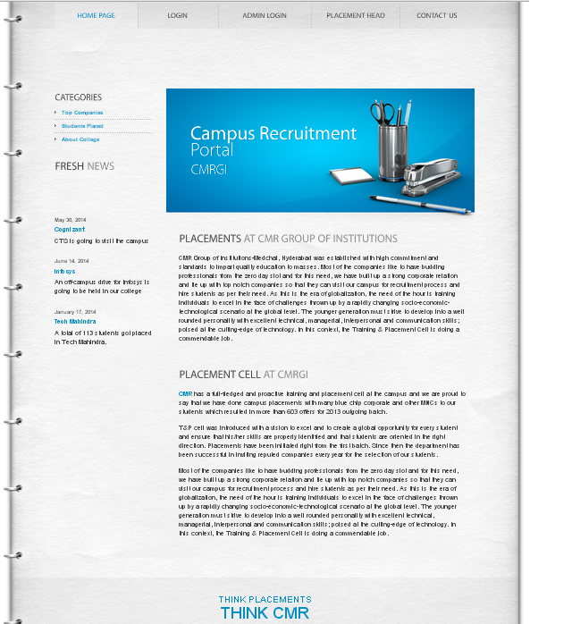

This is the home page of this application. It gives information about the placement cell of the campus.

**7.2 REGISTRATION PAGE**

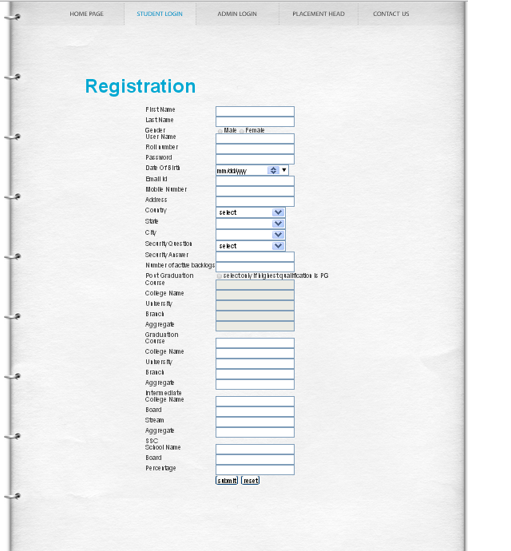

In this page the students get registered with all their personal and academic details.

**7.3 LOGIN PAGE**

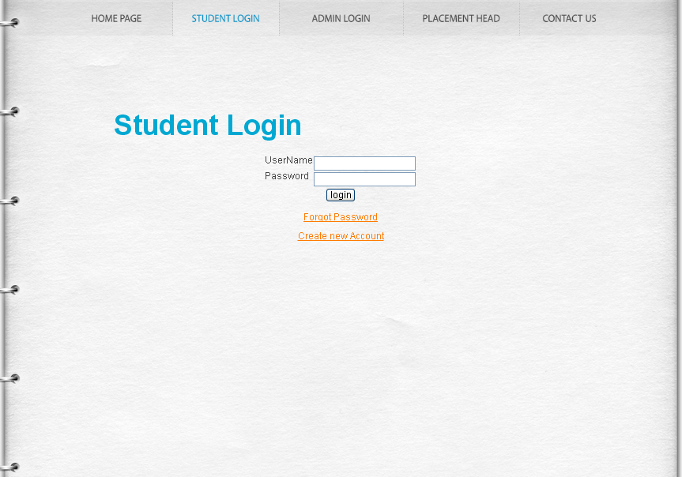

In this page, the student logs in with his username and password.

**7.4 UPLOAD RESUME PAGE**

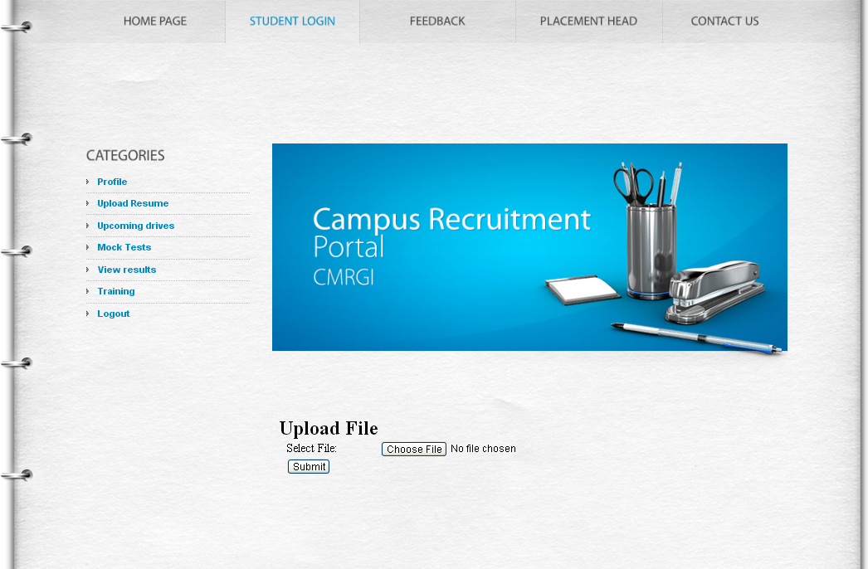

In this page, the student can upload his resume file form the system.

**7.5 PROFILE PAGE**

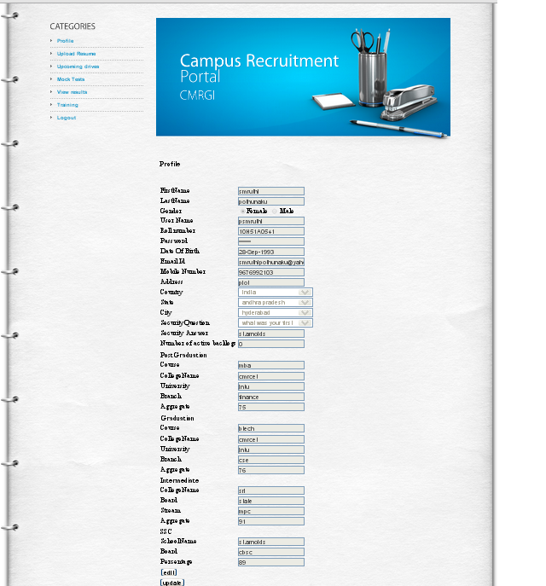

In this page, the student can view and edit his profile.

**7.6 UPCOMING DRIVES PAGE**

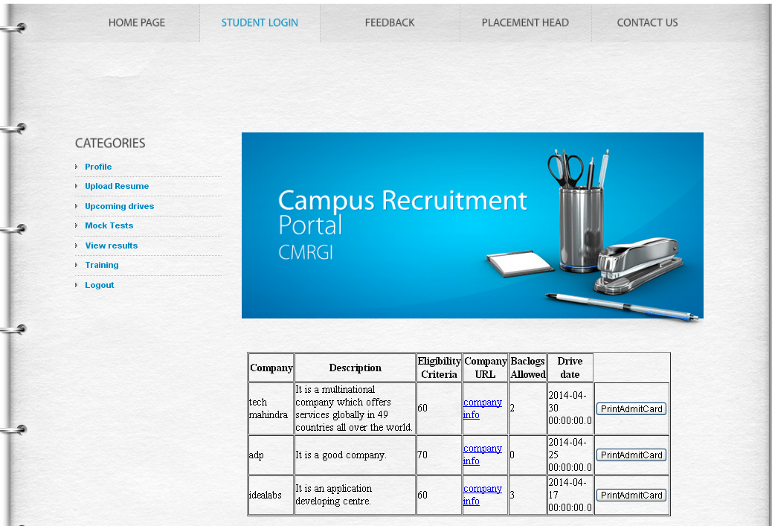

This page gives information of all the companies going to visit the campus and the student can check whether he is eligible or not.

**7.7 MOCK TEST PAGE**

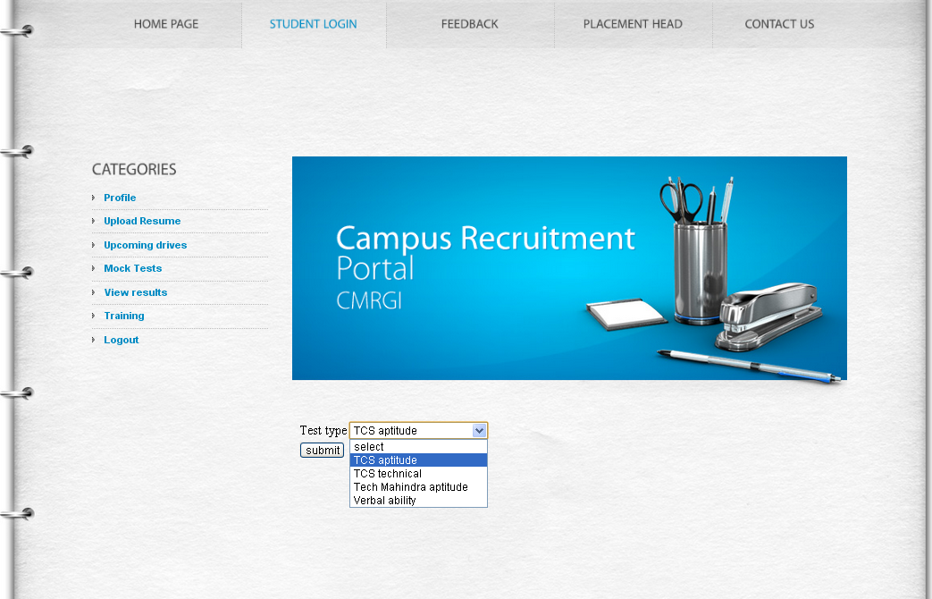

In this page, the student can select a company specific test paper and take test.

**7.8 RESULTS PAGE**

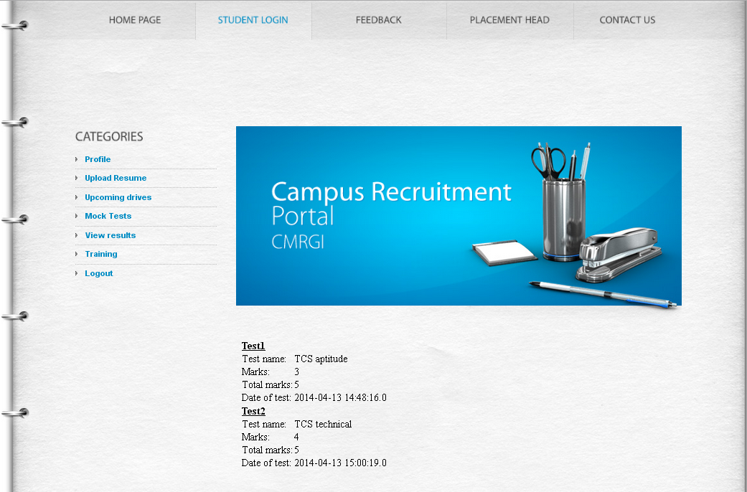

In this page, the student can view the result of the test he had taken.

**7.9 TRAINING DETAILS PAGE**

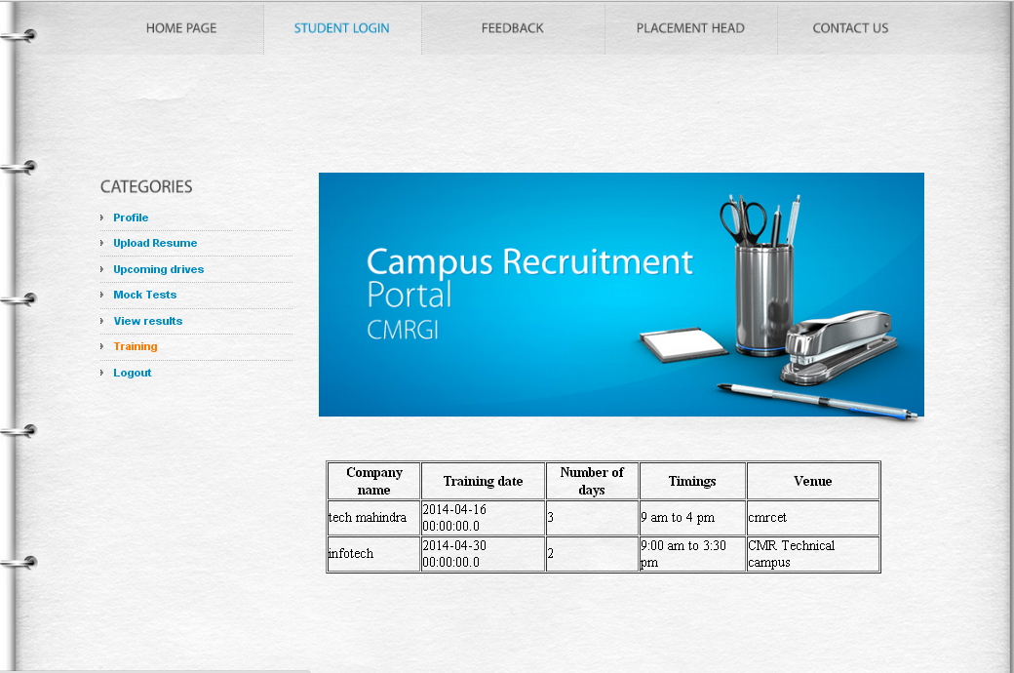

This page gives information about the company specific training details to be organized in the campus.

**7.10 FEEDBACK PAGE**

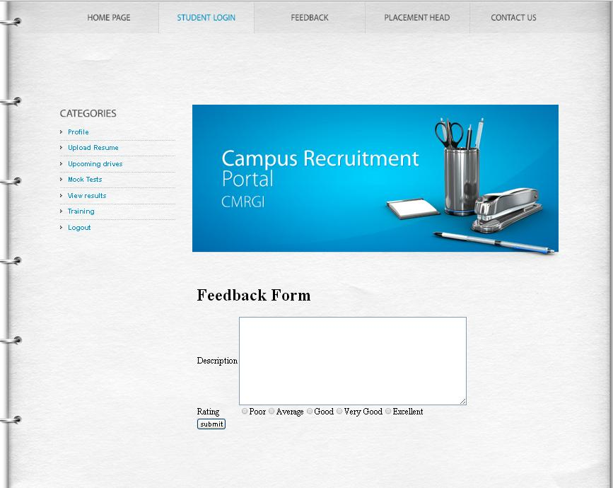

In this page, the student can give their feedback and rate the website/application

.

**7.11 ADMIN LOGIN PAGE**

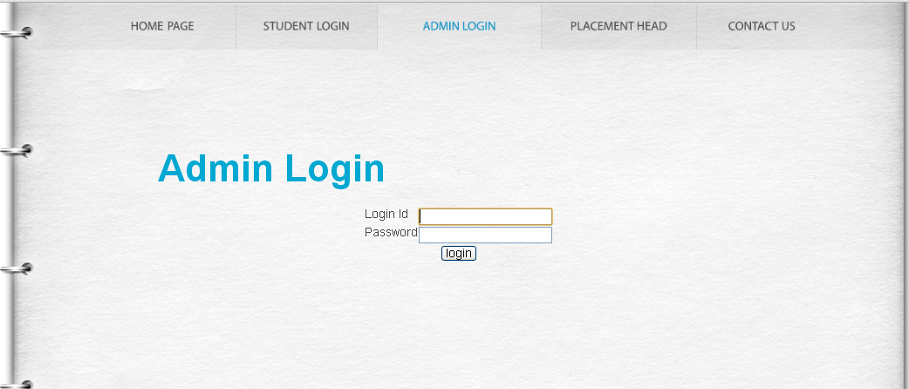

In this page, the admin los in with his username and password.

**7.12 COMPANY PROFILE UPLOADING PAGE**

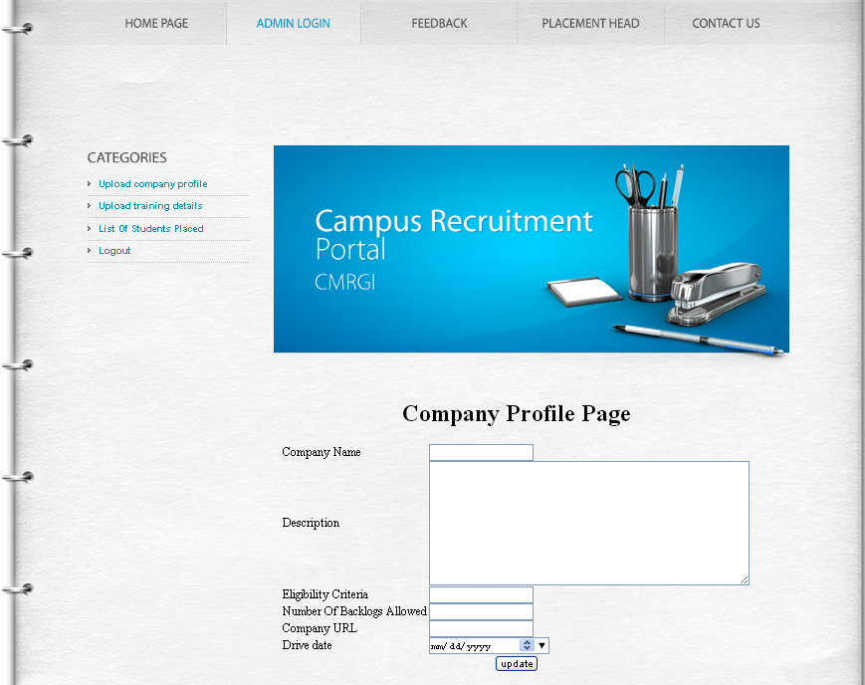

In this page, the admin enters all the details of the company going to visit the campus.

**7.13 LIST OF STUDENTS PLACED PAGE**

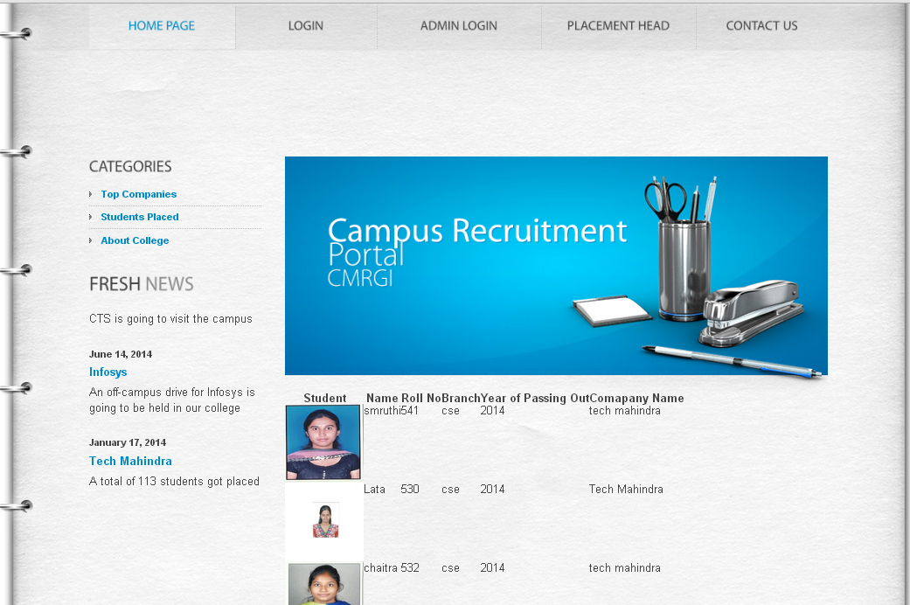

This page provides details of the students placed in different companies.

**7.14 LIST OF TOP COMPANIES PAGE**

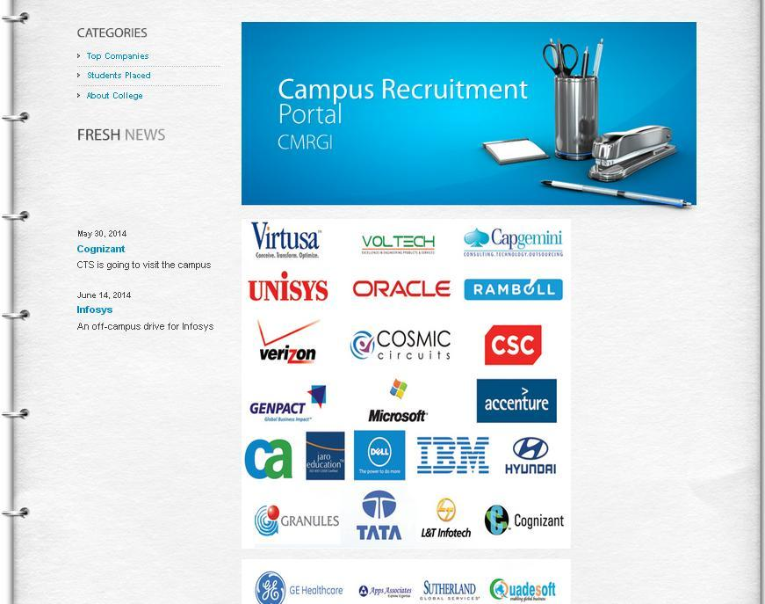

This page gives a list of the top companies that visit the campus.

**7.15 CONTACT US PAGE**

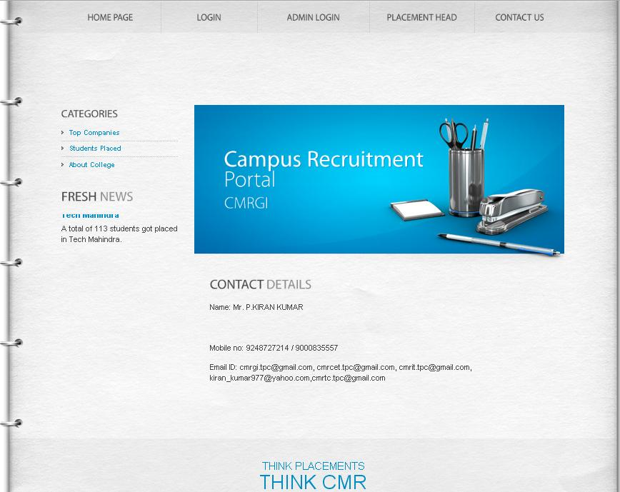

**8. CONCLUSION**

Campus Recruitment Portal is a very user friendly web application which reduces the burden on both students and the placement department of the college. This application provides all the information of the companies going to visit the campus in their portal instead of mailing to each and every student. And the student need not wait for the admit card if he/she is eligible. A hallticket is automatically generated for every eligible student. The student need not search for the company specific test papers, online, it is directly included in this application. This application also includes the training details i.e., timings, venue, company name etc. This application also maintains all the details of the students placed in different companies. Since it serves the students in these many ways, it is a very useful application.

**9. FUTURE ENHANCEMENTS**

In the present version of Campus Recruitment Portal, the test does not have any time limit. In future a timer can be included. Apart from this, a discussion forum can also be included to clarify the doubts of the students regarding the test papers. The performance of students in different drives can be determined and areas of improvement can also be identified. Another enhancement which can be done to this application is uploading some useful materials i.e., frequently asked questions in interviews etc. in the portal

We are also planning to add few video tutorials on group discussions, personal interviews etc so that the students can improve their communication skills. This can be extended to pool campus and off campus drives also.

**BIBLIOGRAPHY**

1. Herbert Schildt, ”**JAVA Complete Reference**” , 7th edition.
2. Judith S. Bowman, “**SQL Handbook**”, 4th Edition, 1986.
3. Patel Moss, “**Java Database Programming with JDBC**”.
4. Rich Helton, “**Mastering JAVA Security**”.
5. Roger Pressman, “**Software Engineering**”, 1990.

**REFERENCES**

1. **Java.sun.com** - The official Java developer website - new articles posted weekly.
2. **www.java.net**- The Java community website hosted by Sun Microsystems.
3. **www.javaworld.com** - One of the originals. Weekly updates of Java articles.
4. **Poi.apache.org** - This website gives the information about apache Tomcat Server.
5. **Wikipedia** for further documentation.